**PROGRAMMING IN JAVA LAB-1**

**PRN-21070126032**

**Name- Harsh Ratna**

**Batch-AIML A2**

**Program Description- Part1: Implement a menu-driven Java program (like fib or factorial) to implement these input methods in java (command line args, Scanner, Buffered Reader, DataInputStream, Console)**

**Part 2:  Implement a simple menu driven calculator in java to implement add, sub, mul, div, sqrt, power, mean, variance. Implement a separate Calculator class to include all related function inside that class. (mean calculation: program reads numbers from the keyboard, summing them in the process until the user enters the string “end”. It then stops input & displays the avg. of numbers)**

Part-1

import java.io.*;

import java.util.Scanner;

class Get_Factorial

{

void fetch_fact(int n)

{

int fact = 1;

for(int i=1; i<=n; i++)

{

fact = fact*i;

}

System.out.println("Factorial of "+n+" is: "+fact);

}

}

public class Factorial

{

public static void main(String[] args) throws IOException

{

Get_Factorial obj1 = new Get_Factorial();

BufferedReader b = new BufferedReader(new InputStreamReader(System.in));

//creating a menu

int choice;

System.out.println("Enter your choice: ");

System.out.println("1. Command Line Arg");

System.out.println("2. Scanner");

System.out.println("3. BufferedReader");

System.out.println("4. DataInputStream");

System.out.println("5. Console");

System.out.println("6. Exit");

choice = Integer.parseInt(b.readLine());

if(choice == 1)

{

obj1.fetch_fact(Integer.parseInt(args[0]));

}

else if(choice == 2)

{

Scanner myObj = new Scanner(System.in);

System.out.print("Enter your number for scanner: ");

int a = myObj.nextInt();

obj1.fetch_fact(a);

myObj.close();

}

else if(choice == 3)

{

BufferedReader a1 = new BufferedReader(new InputStreamReader(System.in));

System.out.print("Enter your number for BufferReader: ");

String n = a1.readLine();

int n1 = Integer.parseInt(n);

obj1.fetch_fact(n1);

}

else if(choice == 4)

{

DataInputStream a2 = new DataInputStream(new FileInputStream("C:\\Users\\nayye\\OneDrive\\Desktop\\JAVA\\input.txt"));

String s = a2.readLine();

int n2 = Integer.parseInt(s);

obj1.fetch_fact(n2);

a2.close();

}

else if(choice == 5)

{

Console a3 = System.console();

System.out.print("Enter your number for console: ");

int n3 = Integer.parseInt(a3.readLine());

obj1.fetch_fact(n3);

}

else if(choice == 6)

{

System.exit(0);

}

else

{

System.out.println("Invalid choice");

}

}

}

**OUTPUT:**

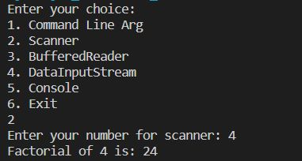

PART-2

import java.io.*;

import java.util.*;

public class Calculator {

public static void main(String[] args) {

Scanner reader = new Scanner(System.in);

int m,k=0,gcd=1;

System.out.print("Menu:\n1)add\n2)sub\n3)mul\n4)div\n5)sqrt\n6)power\n7)mean\n8)variance\n9)GCD\n");

System.out.print("Enter choice: ");

int i = reader.nextInt();

double first,second;

double result;

switch(i)

{

case 1:

System.out.print("Enter first number: ");

first = reader.nextDouble();

System.out.print("Enter second number: ");

second = reader.nextDouble();

result = first + second;

System.out.printf("%.1f + %.1f = %.1f",

first,second, result);

break;

case 2:

System.out.print("Enter first number: ");

first = reader.nextDouble();

System.out.print("Enter second number: ");

second = reader.nextDouble();

result = first - second;

System.out.printf("%.1f - %.1f = %.1f",

first,second, result);

break;

case 3:

System.out.print("Enter first number: ");

first = reader.nextDouble();

System.out.print("Enter second number: ");

second = reader.nextDouble();

result = first * second;

System.out.printf("%.1f * %.1f = %.1f",

first,second, result);

break;

case 4:

System.out.print("Enter first number: ");

first = reader.nextDouble();

System.out.print("Enter second number: ");

second = reader.nextDouble();

result = first / second;

System.out.printf("%.1f / %.1f = %.1f",

first,second, result);

break;

case 5:

System.out.print("Enter second number: ");

second = reader.nextDouble();

result = Math.sqrt(second);

System.out.printf("Square root of %.1f = %.1f",

second, result);

break;

case 6:

System.out.print("Enter first number: ");

first = reader.nextDouble();

System.out.print("Enter power: ");

int p = reader.nextInt();

result = Math.pow(first,p);

System.out.printf("Power %d of %.1f = %.1f",p,first,

result);

break;

case 7:

Scanner sc = new Scanner(System.in);

String s = "";

int count=0;

int total=0;

double avg=0;

int n;

System.out.print("Please enter end to stop taking input: ");

while (true)

{

String input = sc.nextLine();

if(input.equals("end"))

break;

else

{

n = Integer.parseInt(input);

count+=1;

total += n;

avg=total/n;

}

}

System.out.println("Mean is "+avg);

case 8:

System.out.print("Enter how many numbers you want to enter: ");

int o = reader.nextInt();

int ar[]=new int[o];

for(int l=0;l<o;l++)

{

ar[l] = reader.nextInt();

k=k+ar[l];;

}

int mean=k/o;

double sqDiff = 0;

for (int q = 0; q < o; q++)

sqDiff += (ar[q] - mean) * (ar[q] - mean);

result=sqDiff/o;

System.out.printf("Variance = %.3f", result);

break;

case 9:

System.out.print("Enter first number: ");

int n1 = reader.nextInt();

System.out.print("Enter second number: ");

int n2 = reader.nextInt();

for(int h = 1; h <= n1 && h <= n2; ++h)

{

if(n1 % h==0 && n2 % h==0)

gcd = h;

}

System.out.printf("G.C.D of %d and %d is %d", n1,

n2, gcd);

break;

default:

System.out.printf("Wrong choice");

return;

}

}

}

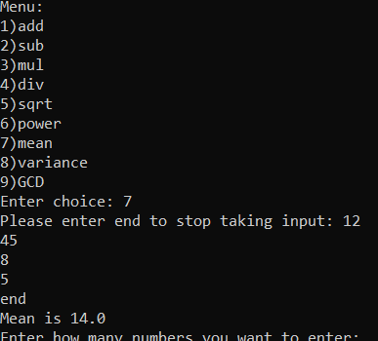OUTPUT:

**GITHUB LINK:**

https://github.com/Harsh-Ratna/Java-Programs/tree/main/Java%20lab%20assignment%201